Including Macroeconomic effects when analyzing regulations towards the Danish Income Insurance Program – Performing a counterfactual analysis in a Stock-Flow-Consistent framework

Abstract

This paper attempts to evaluate the political decision of suppressing the state regulation percentage, voted through by the Danish government in the tax reform of 2012. We do so by estimating the macro elasticity of income insurance on unemployment. We find it important to analyze the full macroeconomic effects as the Danish income insurance model, used by the Danish government to analyze changes to the Danish income insurance program today, do not include any macroeconomic effects. To obtain these macro effects we utilize the quarterly Stock-Flow-Consistent model for the Danish economy developed by Byrialsen et al. (2022). Here we incorporate the Danish income insurance program and five macroeconomic channels, allowing changes in the program to affect the economy. We simulate the model including these five channels to generate an estimate of the change in unemployment associated with each macroeconomic effect both independently and together. We then use these macroeconomic effects together with the microeconomic effects found by the Danish income insurance model to estimate the macro elasticity. We find the macro elasticity to be approximately twice as large as the micro elasticity in the case of Denmark. Using a Baily-Chetty framework including the macro elasticity obtained in this paper, we find evidence that suppressing the state regulation percentage in Denmark was a correct decision looking at the economic welfare. More interestingly, we find this conclusion to be highly dependent on two findings. First, whether the Danish economy is categorized as wage-led or profit-led. Second, the willingness of the worker unions to maintain a high incentive to work, by maintaining a minimum-gap between the level of income insurance and wages. The results of this paper questions the way in which only microeconomic effects so far has been considered when evaluating political decisions regarding the Danish income insurance program.

**Keywords:** Unemployment Benefits, Stock-Flow Consistent Models, Denmark

**JEL-codes:** E12, E25, E57, E01

# Section 1: Introduction

The Danish Flexicurity model is well known worldwide, for being one of the most effective in keeping a low and stable unemployment rate compared to the other European countries. Andersen & Svarer (2006) present three elements of the Danish flexicurity model contributing to the low unemployment rate: i) flexibility in the form of low hiring terms as well as short termination periods, ii) security in the form of generous unemployment benefits, and iii) an active labor market policy. The flexible hiring and termination terms ensure that Danish companies can adjust their workforce quickly according to changes in production, without major costs. The worker unions allow these flexibilities for the firms, because of the high level of unemployment benefits ensuring that individuals will not risk a major reduction in income if being laid off. For unemployed to receive these benefits it is required that they take part in activities improving their human capital, while they at the same time actively search for a new job.

As argued by Kongshøj (2015), the flexicurity model of Denmark has been under pressure in the later years. In this regard, the Danish tax reform from 2012, in which the regulations of unemployment benefits were suppressed for the period of 2016-2023, can be seen as an example of political decisions using reforms with the purpose of increasing economic growth, the level of employment and improving the public balance at the same time. According to this reform, the growth rate of the maximum level of income insurance should be reduced relative to the growth rate of labour income, which is clearly weakening the flexicurity system. Normally, the growth rate is determined by the growth rate in wages, but the government decided to suppress this growth rate of the maximum level of income insurance with 0.3 percent points in 2016, 0.4 percent points in 2017, and 0.75 percent points for the period of 2018-2023.

This paper attempts to contribute to the literature by evaluating the macroeconomic effect of labour market reforms, using the suppression of the regulation of the unemployment benefits in Denmark as a case study. The paper therefore asks whether a lower level of income insurance lead to higher employment, higher growth and improvement of public balances as suggested by the policians and economists in Denmark back in 2012?   
We use a stock-flow consistent model as this allow us to isolate the effect of the decision to suppress the regulations in a counter factual analysis, thereby securing other factors not affecting the results. This approach also enables us to analyze feedback effects both between different sectors of the economy, but also between the real side and the financial side of the economy. Furthermore, it also allows us for investigate the effect of stock-variables, like the public debt, when analyzing the development over time. To the best of our knowledge, we are the first to use a SFC framework to obtain the elasticity of the macroeconomic effects of changes to the level of income insurance on unemployment. Former studies trying to analyze these macroeconomic effects, have used boarder-based approaches, this has led to mixed results possibly due to biased estimates based on violations of the assumptions required for these methods. A Stock-Flow consistent model will overcome these biases, which allows us to discuss the political initiative made in 2012.

This paper makes three important contributions. First, we build upon the empirical SFC-model presented by Byrialsen et al. (2022) integrating the dynamics of the Danish income insurance program, specifically including the variables that are used for political regulation of the unemployment benefits. Second, we perform a counterfactual analysis by removing the regulation made towards the unemployment benefits in the tax reform of 2012, making it possible to evaluate this regulation. Third, this paper contributes to the more recent focus on the aggregate effects of changes in the level of income insurance, looking at the relationship between the micro and macro effects of changes in income insurance.

The paper is organized as follows: Section 1 presented a short introduction of the Danish income insurance program. Section 2, will present the current literature on the effects of changes to the IS-program, focusing on both the micro- and macro-effects. In section 3, we provide a further description of the Danish IS-program by taking a closer look at the IS-model build in 2015, today used by the government to analyze political regulations towards the Danish IS-program. In section 4, we will present a quarterly SFC-model for Denmark, specifically looking at the Danish IS-program by analyzing different macroeconomic channels within the model. In section 5, we use the results from section 4 to obtain a relationship between the macro and micro elasticity of income insurance on unemployment and use these to discuss the welfare effects of completing the initiative from the tax reform of 2012 of suppressing the state regulation percentage. Lastly in section 6, we conclude the results.

# Section 2: Political regulations of the Danish income insurance program

In this section we’ll present the development in the compensation rate for Denmark since 1991 together with a brief review of the Danish income insurance model (IS-model).

## The falling compensation rate in Denmark:

Looking at the generosity of the Danish income insurance program over time, data from ADAM’s databank suggests that the compensation rate, measuring the income insurance relative to the wage, has been falling since 1990-2018, as observed below:

Figure 1

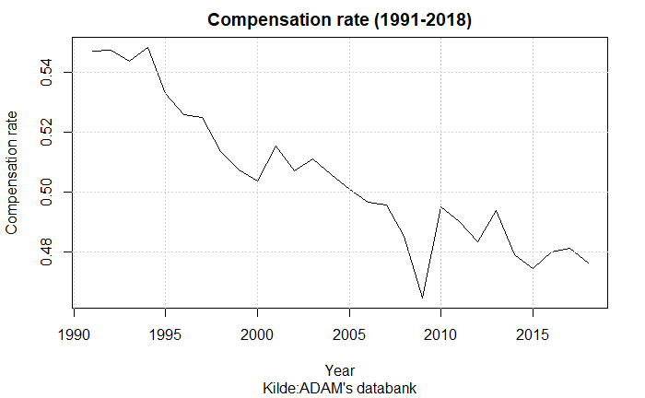

Aastrup (2018), Jensen (2021), and Risgaard (2021) all associate the fall in the compensation rate, to the method used for calculating the growth in the maximum level of income insurance.. In 1995 the Danish ministry of finance legislated a yearly regulation of unemployment benefits (Nørgaard, 1995). The regulation goes through the state regulation percentage which is set to equal 2% each year added by the rate adjustment percent.   
The rate adjustment percent is each year set according to the adjustment percent which is calculated as the change in wages two years prior to the financial year subtracted by two percent points.   
If the adjustment percent is lower than 0%, the rate adjustment percent is equal to the adjustment percent. Is the adjustment percent between 0% and 0.3% the rate adjustment percent is 0%. Lastly, is the adjustment percent larger than 0.3% the rate adjustment percent is equal to the adjustment percent subtracted by 0.3 percent points.   
This creates a situation in which wage growth of more than 2% would result in the maximum level of income insurance not following the wages, making the compensation rate decline over time. The figure below gives an idea of how often the wage has increased by more than 2%.

Figure 2

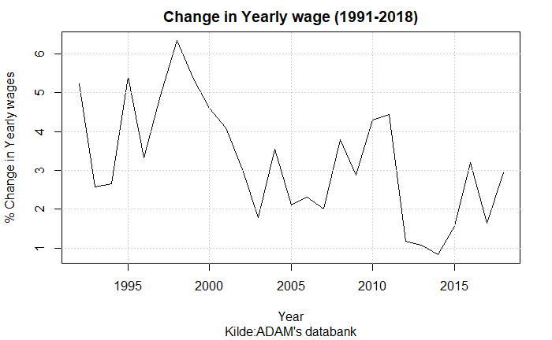

Even though the overall setup of the maximum level of income insurance, ensures that it does not follow wages one-to one, a more recent regulation was made in the tax-reform of 2012 to suppress the regulation of the maximum level of income insurance. We already introduced this regulation in the introduction, explaining how this regulation further reduced the compensation rate starting from 2016, by subtracting up till 0.75% points from the state regulation percentage each year. As mentioned, this paper’s main goal will be to evaluate the decision to carry through this regulation from the tax reform of 2012.

Despite the two main effects described above both contributing to a decrease in the compensation rate over time, other political decisions have been made towards the income insurance program over the last couple of decades. In 2010 the income Insurance reform was adopted, decreasing the period in which an unemployed could receive income insurance from 4 years till 2 years, as well as increasing the requirements for receiving income insurance (IS-Commission, 2015a). Later, to make the cutoff date less strict, updates to the period in which a person could receive insurance were redone making it a smoother transition from the 4-year period to instead 2 years.   
A more recent initiative is made in 2022 making two important adjustments to the IS-program. First, increasing the amount one can get in the first 3 months of unemployment for people with a strong working history. Second, lowering the amount one can get going directly from education to unemployment (DØRS, 2022). Even though these political decisions are important for the IS-program, the effects of these reforms will not be included in the analysis. Neither will they have any effect on the results found in this paper, as we use a set-up isolating the effects of suppressing the state regulation starting in 2016.

Something about the tax reform 2012.

The discussion towards the Danish income insurance program peaked leading up to the Danish election in 2015. The large debate led to a commission set down by the Danish Ministry of employment (IS-commission). The goal for this commission, was to analyze changes to the income insurance program in Denmark, which in 2015 led to the Danish income insurance model (IS-model). The dynamics of this model were built using microeconomic effects which will be presented in a later section, estimating the change in the exit-rate and approach-rate as a result of changes in the level of income insurance. The results of this model favored the lower level of income insurance when looking at the government net lending and unemployment. This led to a response from worker unions and unemployment insurance companies in Denmark arguing that the estimates of the micro effects were not correctly estimated. But most importantly they argued that important macroeconomic effects were missing within the model. In the following subsection we take a closer look at the dynamics of the IS-model, as well as the critics faced by this model.

## The Danish Income Insurance model

Since the creation of the Danish income insurance model in 2015, this model has been used by the Danish government, to analyze the effects of regulations towards the Danish income insurance program.

The IS-model consists of four different parts: A static model for income insurance, a static model for Cash-benefits[1], a Markovmodel, and lastly a re-earning model. Only the first three parts will be presented, as the re-earning model only concern changes towards the rules for re-earning the right to income insurance, thereby not looking at changes to the level of income insurance.

The static model of income insurance is developed to calculate the immediate economic effects for a specific person being unemployed when changing the level of income insurance. For this reason, the static model will not include the behavioral changes that might happen when creating changes in the IS-program. Similarly, the effect on cash-benefits is calculated using the static model for cash-benefits, to see if people would want to switch towards the cash-benefits program instead of the IS-program.

The more interesting part is the Markovmodel built to calculate the equilibrium levels of employment and unemployment, doing this, the population is divided into three groups: Receivers of income insurance, employed, and receivers of other social benefits. The Markovmodel estimates the probability of changing in-between these three groups, thereby looking at changes in the exit rate and approach rate. The exit-rate shows how a change in the level of income insurance changes the departure from unemployment to employment in the period up until the reduction and in the period immediately after. This effect is mostly concerned the unemployed with the best job opportunities to get off income insurance. The model is estimated using the 2010 reform mentioned in the previous subsection showing an effect on the exit-rate up till 78 weeks before a reduction in income insurance and up till 26 weeks after a reduction (Dagpengekommissionens sekretariat, 2015). These behavioral effects are specified as elasticities, meaning that a relative change in the exit rate from unemployment to employment is a function of the relative change in the level of income insurance. Thereby the effects of an increase in the level of income insurance of 30 and 10% will, following their estimates, have the effects of increasing the exit rate by 78% and 26%, at the time of change.

Besides the effect of the exit rate, the IS-commission also includes the approach rate, showing the rate in which people goes from employment to unemployment. Here, the IS-commission only looks at if people in terminated positions, thereby on their way into the income insurance program will find employment before entering the program. One issue is that data can’t show how many people are on their way to enter the income insurance program or how large the exit-rate to employment is for this group.

Therefore, the IS-commission must assume that the behavioral effects for people in terminated positions are comparable to the behavioral effects of people already being in the income insurance program and thereby have been in unemployment for up till almost 2 years[2].

Burde man nævne noget om størrelsesordenen af approach rate?

The majority of the empirical evidence used for the IS-model comes from the literature review made by Andersen et al. (2015). This review was made specifically for the IS-commission, and therefore influenced the effects used in the IS-model. Andersen et al. (2015) specifically looks at the evidence for an effect on the exit-rate and approach rate when raising the level of income insurance. They present 28 different older and newer studies, all focusing on finding an effect on the exit rate. When analyzing the effect of an increase in the level of income insurance, 24 of the studies conclude a significant negative effect on the exit rate, the last 4 studies conclude non-significant negative effects, overall, we find this to justify the use of the exit effect in the model, whereas this effect should be included when estimating the micro elasticity in section 5.

On the other hand, Andersen et al. (2015) only presents three studies looking at the approach rate when changing the level of income insurance, the two newest studies Falch (2015), and Jurajda (2002) finds no significant effects. Andersen et al. (2015) find that the only study showing significant effects is an older study by Topel (1983) using American retrospective data from 1975. This lack of empirical evidence has led to the large amount of critic towards the use of the approach effect.

Jensen (2021), and Aastrup (2018) all argue that the behavioral effects used to estimate the costs of an increase in the level of income insurance is misleading due to the inclusion of the approach rate, and the IS-commission is therefore overstating the costs of increasing the level of income insurance.. The IS-Commission (2015b) also themselves mention that there is very low empirical evidence for this effect even existing.  
Risgaard (2021) add to the discussion that they don’t see the income insurance at a level where it should be pulling employed into unemployment, they argue that a large percentage of the group experiencing the highest level of compensation rate are still in job.

the inclution of the approach rate leads toFurthermore, they also conclude that in newer literature, the estimate of the approach rate given by the IS-commission, is overestimating the negative effect that the approach rate has on employment.

To sum up ….

# Section 3: Literature review

In the later years there has been a large amount of literature discussing the effects of unemployment benefits, mostly focusing on the link between the compensation rate and employment. A large part of the literature investigating the incentive to work, and job-search, has been reviewed by Andersen et al. (2015) they find that the majority of the literature show evidence for a higher movement from unemployment to employment when reducing the unemployment benefits, thereby increasing the exit-rate from unemployment. The two main effects associated with the exit-rate are the Moral Hazard and Liquidity effect, both build on a micro foundation. Chetty (2008) finds that the liquidity effects explain 60% of the effect on the unemployment period when changing the level of income insurance. In contrast to effects like the Moral Hazzard effect, where income is the only factor when looking at incentives to work, Howell & Azizoglu (2011) provide another link as they find a positive relationship between working and happiness, independently of income insurance, thereby questioning the often-argued positive relationship between working and disutility.

Andersen et al. (2015) also address the approach effect using a micro foundation it shows that a relationship should exist between the movement from employment to unemployment and the level of income insurance, they add that at the given time the literature towards the approach effect is still sparse, not showing any significant movement (from employment to unemployment) when changing the level of income insurance. The Economic council of Denmark, DØRS (2022), argues that the lack of new literature towards the approach effect, is mostly explained by the newer literature moving away from the narrow micro founded point of view of only looking at the effects on the behavior of unemployed and employed.  
Instead, newer literature focus on aggregated effects of changes in the unemployment benefits, and thereby estimate a macro elasticity for income insurance on unemployment. Fredriksson & Söderström (2020) looks at the aggregated effects of a reform in Sweden concluding that the number of unemployed increases by 3% when increasing the income insurance ceiling by 1%. They find that this macro elasticity is twice as large as the elasticity coming from the micro founded effects of changing behavior of unemployed. On the other hand, a study by Boone et al. (2021) finds that the aggregated effects are almost zero, but still points out the importance in finding the relationship between the micro and macro elasticity. As will be further discussed in section 5, the empirical evidence at this point seems inconclusive considering macroeconomic effects when evaluating political decisions towards unemployment benefits.

Post-Keynesian literature on the other hand, pays much more attention to the aggregated effect, since the level of employment and real wages are determined by the level of effective demand. This implies that an increase in the aggregate demand will raise the level of economic activity, creating more jobs. Dray & Thirlwall (2011) suggest that demand can create its own supply within limits, therefore it makes little economic sense to see growth as supply constrained. This implies that we should focus on the income distribution determinants of aggregate demand, paying less attention to the supply-side factors. In general, post-Keynesians have proposed redistributive policies, favoring an increase in social expenditures – including unemployment benefits – which are important for income distribution. Post-Keynesians take in regard both fairness, in the form of lower inequality, and the economic gain from favoring income distribution, the last depending on whether the policy is considered to be pro-labor or pro-capital. As described by Stockhammer & Lavoie (2013) pro-labor distributional policies are those increasing the wage-share whereas pro-capital distributional policies usually claim to promote ‘labor market flexibility’ or wage flexibility, rather than increasing capital income. Increases in the unemployment benefits are therefore seen as a pro-labor policy. If a pro-labor policy is found to expand the economy, it is called a wage-led regime, on the other hand if this contracts the economy it indicates a profit-led regime.

Looking at which macroeconomic channels that the literature suggest should play a role when analyzing the level of income insurance, the first channel follows the idea of post-Keynesian theory suggesting that a higher level of income insurance should lower the unemployment through a higher aggregate demand. This demand channel suggests that changes in level of income insurance affect the level of aggregated demand and thereby the demand for employment. Another channel is introduced by Andersen et al. (2015) finding empirical evidence that unemployment benefits has a positive relationship with wages. It is argued that a change in the level of income insurance will affect the wage negotiations, expecting that a higher level of income insurance would increase the targeted wages demanded by the worker unions, who wants to maintain a high incentive to work. The effects of a higher wage given by Andersen et al. (2015) is mostly based on micro level explanations where the wage will have a negative effect in the form of lowering the demand for labor, thereby increasing the number of unemployed. Byrialsen & Raza (2018) also include a positive relationship between the level of income insurance and wages from a macroperspective, when including the compensation rate in the wage equation. arguing that this is in line with standard models of wage setting, which plays an important role in the determination of the targeted wage (Mcdonald & Solow, 1981; Shapiro & Stiglitz, 1984).

A third macroeconomic effect is based on the previous discussion, whether we should use the liquidity or Moral Hazard effect, when explaining the effect on the exit-rate. Of these two, the most commonly used explanation is the Moral Hazard effect. Chetty (2008) on the other hand finds that 60% of the effect on the unemployment period from an increase in the level of income insurance can be attributed to the liquidity effect. This implies that the unemployed seems to be experiencing a budget constraint, as they are using their savings to keep a higher level of consumption. When one’s savings are running low (which will take longer the higher the level of income insurance), that person might be more likely to accept jobs that are not socially efficient. If the liquidity effect is present, when decreasing the level of income insurance, this could lead to a matching effect resulting in a worse job match between employer and employed, not taking advantage of the higher productivity the employer could have had in another job position with a better match.   
  
Andersen et al. (2015) presents several studies, all indicating that a more generous income insurance program results in an extended unemployment period, approximately half of the studies find positive effects on the match-quality, the other half find no effects, and one study finds significant negative effects. The majority of the studies only find evidence using changes in the income insurance period, and not the level of income insurance, whereas the empirical evidence that productivity should be affected by changes to the level of income insurance is very sparse.   
A possible explanation for the weak empirical evidence is also presented by Andersen et al. (2015) who shows evidence for a reverse effect of income insurance on the productivity, they argue that as people are spending longer time unemployed, their human capital falls, lowering their productivity[3]. This may be capable of explaining the mixed empirical evidence for a channel existing between the level of income insurance and productivity.

Additionally to the matching effect, Millemaci & Ofria (2014) present the Verdoon-effect arguing that labor productivity usually is found to be procyclical. This effect is also used by Fazzari (2020), who use the unemployment rate as a regressor of productivity explaining that when there is higher economic activity, R&D expenditures also tends to rise, thereby increasing productivity.

A macroeconomic channel not getting that much attention in the literature, is the effect of income insurance on the participation rate. Fazzari et al. (2020) endogenizes the labor force using the strength of the economy measured by the unemployment rate as a regressor. He argues that the unemployment rate should have a negative relationship with the labor force. The main reason is that a decline in labor force participation should imply a rising difficulty of finding an acceptable job match as unemployment rises, additionally evidence suggests that higher unemployment also tends to reduce immigration, also affecting the labor force (Setterfield, 2003).

Lastly, as the income insurance program is not mandatory in Denmark, it is argued that one should expect a lower compensation rate to affect the insurance rate (The rate of workers being a member of the income insurance program) (Aastrup, 2018; Jensen & Nørgaard, 2021; Risgaard, 2021)[4]. Interestingly it is found that in the same period as the fall in the compensation rate, the percentage of the working force being a member of the income insurance program has dropped from 84% till 78% even though this period has included political adjustment intended to raise this percentage (Risgaard, 2021). Aastrup (2018) includes several channels in which a higher insurance rate affects the economy, most importantly, he argues that it leads to higher stabilization at lower economic activity by keeping the aggregate demand high.

# Section 4: Including macroeconomic effects in a quarterly Stock-Flow-Consistent model for Denmark.

In this section, we will present the model used to analyze the macroeconomic effects. For this, we utilize the features of a stock-flow consistent framework building upon the existing empirical stock flow consistent model for Denmark developed by Byrialsen et al. (2022). We contribute by adding and endogenizing a number of relevant features to the labour market, including the income insurance system to the existing model. In this presentation of the model, we will focus mostly on our contribution to the model, while the rest of the model is presented as a system of equation in the appendix.[5]

## Fundamental equations in baseline model

As Denmark is a small open economy with fixed exchange rates, Byrialsen et al. (2022) adopt small open economy assumptions, which allows global shocks to affect the Danish economy while domestic shocks are irrelevant for the global economy (thereby treating the global economy as exogeneous).  
The model consists of 5 institutional sectors: non-financial corporations, financial corporations, the government, households, and the rest of the world. As our focus is the dynamics of the labor market, it is worth noting that due to a high rate of employment the Danish economy is very likely to face labor shortages in the labor market. This feature is introduced in the model, since even small changes to the unemployment rate affects wages and thereby prices.

To start off with, we assume that real total production takes place in the non-financial corporations and is determined by the aggregate demand, as seen below

The level of real production, together with real productivity of workers determines the level of employment.

The level of unemployment is defined as the difference between the amount of people employed and the labor force, as seen below:

The labour force is determined by the participation rate and size of the population.

While the population is determined exogenously, we assume the participation rate, and thereby the labour force to be affected positively by the economic activity, which creates a link between the demand effects of unemployment benefits and the labour force (which we will refer to as the Labor force channel). This mechanism is integrated to the model through the rate of unemployment as seen in the equation[6]:

Due to the existence of the income insurance system, a percentage of people within the labour force being unemployed also receive an income. The level of unemployment benefits in Denmark is linked to the development of the wages in the economy, since it on an individual level constitutes around 90 % of the previous salary. The level of unemployment benefits therefore increases with the increase in wages until it reaches the maximum level of income insurance (), which has been adopted from political side. Following the approach by the ministry of finance, a maximum can be estimated within the model.[7]

The maximum level of income insurance grows by the state regulation percentage () plus the rate adjustment percentage () each year.

As the Ministry of Finance determines the state regulation percentage, we choose to make it exogenous within the model. On the other hand, the rate adjustment percentage is calculated each year, using the adaption percentage, following rules specified by the Danish legal-authorities: First, if the adaption percentage is lower than 0 the rate adjustment percentage is equal to the adaption percentage. Second, if the adaption percentage is between 0.0 - 0.3% the rate adjustment percentage is set to 0. Third, if the adaption percentage is above 0.3% the rate adjustment percentage is equal to the adaption percentage minus 0.3% points.   
As with , the rate adjustment percentage is calculated in the first quarter and held fixed to the end of the year.

The adaption percentage is calculated by taking the wage growth two years before the financial year subtracted by 2% point, it should be noted that we use the yearly wage growth which in the model is calculated using the first quarter, therefore, the adaption percentage is only calculated for first quarter and held constant for the rest of the year.

To calculate the average level of income insurance per person (), we use a simple OLS regression linking the maximum level of income insurance to the average benefits received by unemployed, being a member of the IS-program. Looking at data from ADAM’s databank, we know that approximately 85% receives the maximum level of income insurance. This implies that the 85% receiving the maximum level of income insurance will experience a one-to-one increase in their level of income insurance, when the maximum level of income insurance increases. On the other hand, people not getting the maximum level would experience a lower increase or even no increase at all in their level of income insurance, depending on whether the increase in the maximum level of income insurance is because of higher wages[8]. For this reason, we know that the coefficient should be between 0.85 and 1, which is also what we find when estimating the coefficient to be 0.9507 in the equation below.

The endogenization of is now completed, allowing us to calculate the compensation rate within the model. The compensation rate is estimated as the fraction of , to the average wage received by workers ().

The average level of income insurance ), is then transformed into an aggregate variable, multiplying it by the number of unemployed and the insurance rate[9] giving the total amount paid in income insurance to the households .

Next, we include the insurance rate channel, as presented in section 2, many organizations criticize the IS-model for not including a relationship between the compensation rate and people’s choice in joining the insurance program[10]. Such an relationship should exist as people are comparing membership costs to the generosity of the program, and as the compensation rate gets lower, more people are not willing to pay these costs, thereby these people end up leaving the program (Aastrup, 2018; Jensen & Nørgaard, 2021; Risgaard, 2021). The central mechanism of changes in the insurance rate, will go through the demand side of the economy as we change the percentage of people receiving income insurance when unemployed[11]. The equation added to the model can be observed below:

Data used for the insurance rate is obtained from ADAMS databank, and as the data is only available till 2018, we are only able to estimate the equation till 2017 quarter 4. Doing this, we find a positive long-run relationship between the compensation rate and the insurance rate but only at a 10% significance-level.

The total amount paid in income insurance to the households then feeds into the households’ disposable income, and thereby affecting consumption of the households (). In contrast to Byrialsen et al. (2022) we split the net benefits up into two components (), and (), where the later one determines the total amount of income insurance received by households, while the first determines all other benefits received by households. The effect of the net benefits received by households feeds into the disposable income through the component of current transfers ().

Another important element of household income, which might also be affected by the level of unemployment benefits is the wages. We determine the wages as follows within the model.

In the wage equation we include a long run relationship with the targeted wage, as a way of modeling the wage negotiations. The literature presented in section 2 suggested that incorporating the level of income insurance is in line with standard models of wage setting, thereby playing an important role in the determination of the targeted wage. In the baseline model we assume that the labor unions got two agendas when determining the target wage. First, they want the wage to follow inflation so that workers keep their purchasing power over time. Second, they set a threshold for the minimum wage gap, measuring the difference between the wages and maximum level of income insurance relative to the wages, to maintain a certain incentive to stay employed. In the model we set the minimum wage gap to 42% of the wage, thereby, we estimate a relationship between income insurance and wages close to the one found by Fredriksson & Söderström (2020) showing an elasticity of 0.2-0.3 between the replacement rate and wages. In the case where inflation is not able to close the minimum wage-gap alone (thereby leaving the gap to be below 42% of the wage), the labor unions set the targeted wage so that the wage gap is exactly 42% of the wage. The equation for the target wage and the wage gap can be seen below:

We have now established the link between unemployment benefits and the rate of income for unemployed as well as the wage rate for workers, which allows us to move towards focusing on the decision to consume among the households.

The disposable income among the households is assumed to be divided into one component consisting of wage income and social transfers and one component consisting of profits and income of property, in order to capture different propensities to consume out of different sources of income as well as different taxes on income.

Following standard Keynesian theory consumption can be modelled as a function of disposable income and wealth. As stated above, our approach differentiate itself from most empirical models, by dividing disposable income in two components with different propensities to consume.

Regarding household’s consumption, we find cointegration between the real consumption and both real disposable income and real financial wealth. Therefore, the consumption function is estimated using an error correction model, taking the following form:

As presented unemployment benefits affects the economy through different channels. Changes in the level of benefits, therefore both affect the disposable income of household via the effect on social transfers and the effect on nominal wages.[12] Since the wagebill is a cost for the firms, the effect of unemployment benefits on nominal wages affect the profits of the firms, just like the changes of the level of unemployment benefits affect the expenditures side of the public balance.

Asides from affecting household consumption, changes in disposable income also affects household investment in dwellings. Changes in household consumption (and household investment) affects aggregate demand, which affects other demand component via standard Keynesian mechanism: import is affected by domestic demand and real exchange rate, export is affected via foreign demand (which is determined exogenously) and real exchange rate. Since the level of investment by firms follows a standard multiplier approach, investment would react pro-cyclical to changes in the level of aggregate demand[13]. Finally, both government consumption and investment are assumed to be exogenous, these are not affected by changes in the economic activity.

While neither public consumption nor public investment is endogenous, the public balance is still affected due to the automatic stabilizers in the model. On the income side, the tax revenue of the government will be affected by the changes in economic activity, due to changes in the level of employment. On the expenditure side, the number of unemployed, who receive unemployment benefits is also affected by the economic activity. We assume for simplicity, that the government finances the entire Income insurance system, which is not the case in reality. The effect of a change in the level of income insurance will therefore overshoot the effect on government net lending[14].

## Validation of the model

In this section we look at the performance of the model, comparing the simulation results of the baseline model with actual data, we keep a specific focus on the variables in the labor market.

In the figures below we compare the simulated and actual data for GDP, Employment, maximum level of income insurance, and the compensation rate.

Figure 3: Simulation vs. real data.

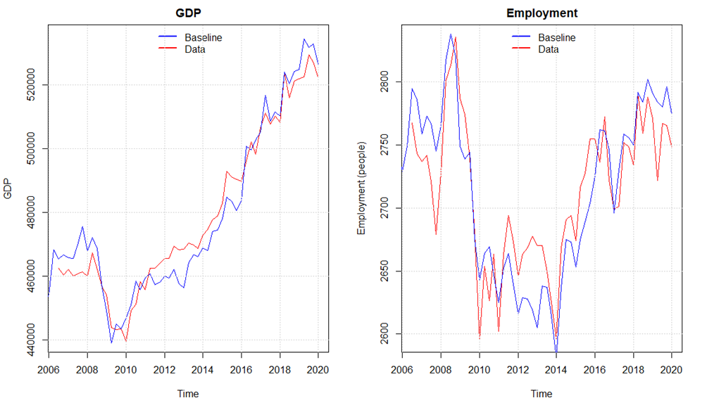

It seems like a small overshooting of the economic activity in the period 2011 – 2016 can be identified. This can be explained by a higher simulated value of real investment and consumption compared with the data. Overall, the model seems to capture the medium to long-run tendency of the data even though there are some divergences in some quarters. The overshooting in the activity also results in a higher level of the maximum level of income insurance in some periods, due to higher wage growth. As the increase in wage growth also goes directly into the compensation rate in the same period, meanwhile the maximum level of income insurance will be affected with a lag of 2 years, we observe that the compensation rate is a bit higher in the baseline compared with real data in the period of 2010 - 2012, but as the adjustments to the income insurance through higher wages happens, we again find a good match with the real data.

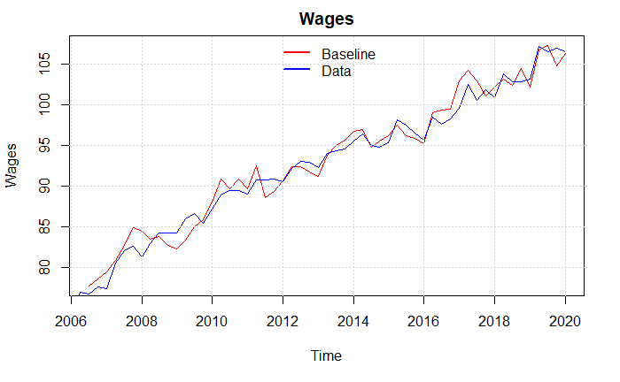

Figure 4: Simulation vs. real data

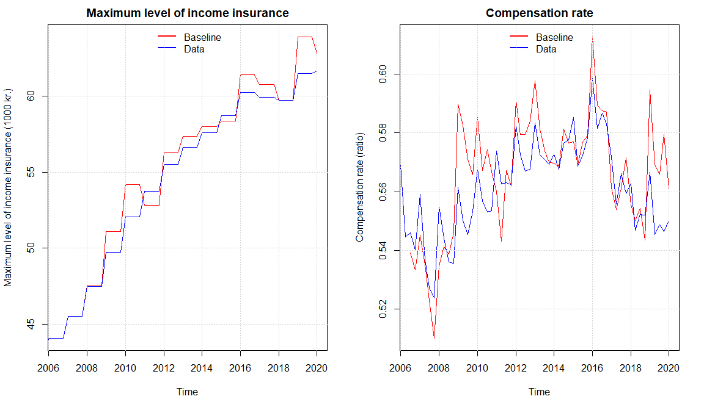

From the figure above we see that the compensation rate is slightly increasing, especially in the period of 2008-2016, we attribute this to a slowdown in the growth rate of wages. Comparing with the results of DØRS (2014) the development fits very well, they as well use a macro-based calculation of the compensation rate, finding that the compensation rate increases within this period. Most importantly, our baseline model shows a fall in the compensation rate in the period of suppressing the regulation of the maximum level of income insurance starting in 2016. Which was also expected looking at the forecasts made by DØRS (2014).

# Section 5: Result and Discussion

After creating a baseline model, we introduce a number of scenarios removing the suppressing of the state regulation percentage starting from 2016Q1 under different settings, in order to analyze the effects of changing the level of unemployment benefits. In the first scenario all channels presented in the description of the model are activated. In the second scenario, the link between unemployment benefits and labour force is weakened. The motivation for this scenario can be found in recent work by the Danish reform-commission, which claim that the group of people outside the labour force is unaffected by labour market reforms (Smith 2021). In the third scenario, we add another element to scenario 2, by removing the link between unemployment benefits and wage setting. The motivation for this scenario can be explained by looking at the development in compensation rate over the last couples of decades. It can be argued that the fall in compensation rate over the last couple of decades has widened the gap between unemployed benefits and wages to a degree, where a small reduction of this gap shouldn’t affect the wages.

## Scenario 1: Removing the suppressing the state regulation percentage.

In this first Scenario, we perform a counter factual shock in removing the suppressing of the state regulation percentage, determining the growth in the maximum level of income insurance. The state regulation percentage is usually fixed at 2% but due to the tax reform of 2012 it is subtracted by 0.3 percent points in 2016, 0.4 percent points in 2017, and 0.75 percent points in 2018-2020.   
Therefore, we introduce the shock by keeping it fixed at 2% for the entire period. As we perform this shock on the Baseline model, the increase in the level of income insurance, will affect the economy both through the Demand, Wage, Insurance rate, and Labor force channel.

In the figure below, we find that in scenario 1, removing the reduction in the level of unemployment benefits affects the economy positively in the very short run. This effect can be explained by the fact, that an increase in the level of unemployment benefits creates an increase in the income of households, which affect the economic activity positively. After the first quarter however, the effect turns negative relative to the baseline. This negative effect on GDP can be explained by several channels. Firstly, the increase in the maximum level of benefits relative to the baseline level reduces the gap between the maximum level of benefits and wages below the threshold of 42%. The effect of this is, that the targeted wage will be adopted with the purpose of remaining the gap at 42 %. As the targeted wage increase, so does the wages and prices, which has a positive effect on consumption, but a negative effect on the level of competitiveness, which reduces the net export. Finally, the increase in wages lead to an increase in the wage share (and reduction in profit share), which, together with the fall in economic activity, has a negative effect on investment. Secondly, the lower economic activity reduces the level of employment, which increases the level of unemployment as well as the rate of unemployment. The increase in the rate of unemployment reduces the participation rate and thereby the size of the labour force. Since the reduction in the labour force is smaller than the reduction in the level of employment, we see an increase in the level of unemployment of around 200 people 2 years after the shock and around 500 people four years after the shock. Following Post-Keynesian literature, this result indicate that the Danish economy can be characterized as being profit-led, since a labour-oriented distribution policy leads to a fall in the economic activity.

## Scenario 2 Denmark as a mature economy

In this scenario we take a closer look at the assumption for the labor force channel, as described this includes a relationship between the economy activity and the decision to join the labor-force. As argued by Smith (2021) however, these types of reforms aimed at changing the incentives for people to participate in the labor force by reducing the benefits, seems to have almost no effect at these times, since those who would be affected by these reforms are already part of the labor-force. Furthermore, the rate of unemployment in Denmark is so low, that lowering it even further might not have the same effect on the decision to join the labour force as expected with higher rates of unemployment. In other words, the labour force is considered to be exogenous in this scenario, which supports the arguments, that participation in the labour force is explained by factors not included in this model, like norms, wages relative to other workers, consumption levels, and the standard of living.

As the case of scenario 1, we see a positive effect of removing the reduction in the level of unemployment benefits in the very short run, due to the higher income among the households. In the short to medium run, the result of scenario 2, follows the one from scenario 1 with minor differences, since the effect of a change in labour force has been removed from this scenario. As in scenario 1, the increase in the maximum level of benefits relative to the baseline level lowers the wage gap and activates the 42% rule increasing the targeted wage. This increase in the targeted wage leads to higher wages and prices, which on the one hand increase the household consumption, but at the same time reduces net export through higher relative prices and investment through a lower profit share and the accelerator-effect, as explained in scenario 1. The lower economic activity reduces the demand for employment. Since the labour force is unaffected in this scenario a reduction in the level of employment lead to a one-to-one increase in the level of unemployment. As seen from figure x, the level of unemployed increases with around 250 people after two years and around 700 people after four years. Comparing with scenario 1, the effect on the level of unemployment is larger in this scenario. Focusing on the effect on GDP, however, tells the opposite story, since the drop in GDP in this scenario compared to scenario 1 is slightly reduced. This might be seen as a puzzle, but can be explained by the fact, that the labour force is unaffected in this scenario. As explained above, the reduction in the level of employment results in a one-to-one increase in the level of unemployment (and rate of unemployment), which reduces the increase in wages and prices compared to scenario 1, which reduces the negative effect on both net export and investment compared to scenario 1. Despite the minor differences between the two scenarios, the overall result of a negative effect of this scenario on both the level of unemployment and the economic activity still holds.

## Scenario 3 Removing the effect on wage negotiations

In this scenario we will take a closer look at the assumptions for the wage-channel, in which changes to the maximum level of income insurance affects the targeted wage set by worker unions. As presented earlier, the rate of compensation has been reduced over the last couples of decades, which point in the direction of a weaker link between maximum level of unemployment benefits and wages. We, therefore, use the above argumentation to assume that changes in the maximum level of benefits does not affect the targeted wage set by worker unions, and will therefore have no effect on the wages.

As seen in figure x, removing the effect on the targeted wage actually change the overall effect of a change in the level of benefits, since it actually reduces the number of unemployed with 100 people over 2 years and 300 people over 4 years. The reduction of level of unemployed is explained by the increase in economic activity. This increase in the economy in the very short run is, like in the previous scenarios, explained by an increase in the part of household coming from social transfers. Unlike the situation in scenario 1 and 2, no crowding out effect on wages and prices can be found directly as a result of higher level of benefits. Instead the higher economic activity leads to higher level of employment, which with a fixed labour force, result in a one-to-one reduction in the level of unemployment. The lower rate of unemployment affects wages positively, which combined with higher level of employment result in an increase in the wage bill of the households. This leads to an increase in household consumption (and investment), which exceeds the fall in investment and net export. To use the terminology of Post-Keynesian theory – the institutional changes in this scenario makes the Danish economy wage-led.

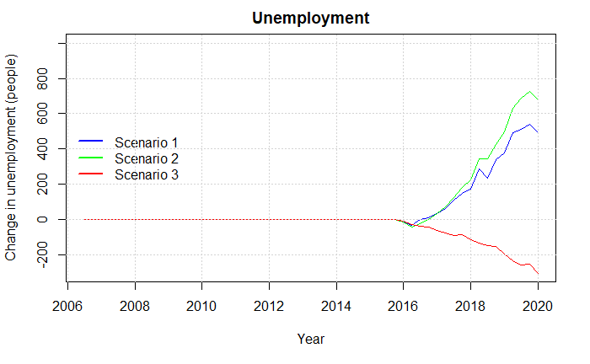

Finally, except from the effects on the level of unemployment and economic activity, the government used improvement of the public balance as another reason for the reform back in 2012. Figure x illustrates the effect on the public balance in the three scenarios. At first glance, the result might seem surprisingly. Except from the expenditures related to higher benefits per unemployed, the main effect on the public balance in this model is due to the automatic stabilizers. Since the economic activity only increases very little in the very short run in all three scenarios, the higher level of expenditure per unemployed exceeds the positive effect from higher tax income (and fewer unemployed). In the short- to medium-term, the effect on the public balance diverges among the three scenarios. In scenario 1 and 2, the increase in the level of unemployment benefits results in an increase in wages, which, despite the fall in employment, has a positive effect on the tax revenue of the government. This increase in tax income of the government, exceeds the increase in the unemployment benefits despite an increase in the level of unemployment, which establish an overall positive effect on the public balance. After 4 years however, the effect turns negative in both scenarios, which is explained by the fact, that the effect on wages disappears as the gap between the level of maximum benefits and wage widens, which reduces the wages and therefore the tax revenue. In scenario 3 on the other hand, the effect on the public balance is negative both in the short and medium run. In this scenario, the increase in the benefits doesn’t affect the wages directly. This combined with the relatively small effect on the economic activity, leads to a reduction in the government savings, while the level of investment is unaffected by the shock.

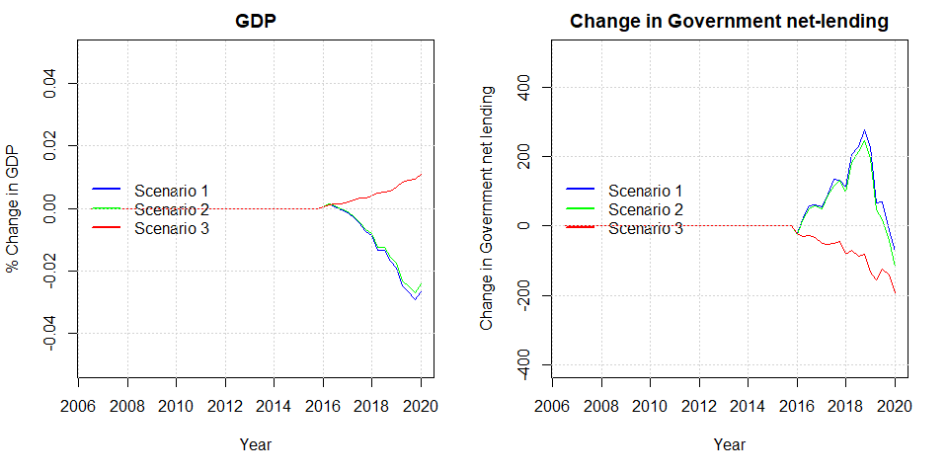

# Section 5: Evaluating regulations towards the Danish income insurance program

As seen from the results above, the overall effect is highly depended on the settings, under which the shock is carried out. For this reason we will discuss the different conclussions obtained when using the different scenarios found in section 4, to calculate the macro elastic, in order to qualify the discussion of the reform.

As presented in section 2, the literature regarding income insurance is moving more towards estimating the full macro elasticity, instead of the often-used micro elasticity found by the Danish income insurance model. Fredriksson & Söderström (2020) concludes that when not knowing the macro elasticity relative to the micro elasticity of income insurance, it is not possible to make the right political decisions. If the macro elasticity equals the micro elasticity, then the Baily-Chetty formula applies directly (Baily, 1978; Chetty, 2006). If the macro elasticity is greater than the micro elasticity, and there are aggregate inefficiencies, then income insurance should be set lower than the level dictated by the Baily-Chetty formula. A key question is thus whether the macro elasticity is greater/lower or equal to the micro elasticity. (Fredriksson & Söderström, 2020)

To calculate the macro elasticity for Denmark, we use the same idea as Lalive et al. (2015) where calculating the macro elasticity implies taking the sum of the micro effects and macro effects. So, if finding significant macro effects, as we do in our study, we can use those together with the micro effects of the IS-model to obtain an estimate of the macro elasticity[15].

We estimate the micro elasticity for the Danish economy using calculations presented by the ministry of labor, using the IS-model to provide the effects of removing the suppressing of the state regulation percentage in the period 2020-2023[16]. They estimate that removing this regulation will leave the level of income insurance to increase by 2.25%, and thereby lower employment by 2900 people[17]. This is further split up showing the effect associated with the exit-rate (1600 people) and the approach-rate (1300 people) independently (Hummelgaard, 2021). As mentioned by Jensen (2021) the approach rate in this example contributes with 45% of the total effect, which they find to be very unrealistic.

When estimating the micro elasticity, we therefore include different measures of the approach effect in our analysis. Besides following the estimates of the IS-model (where the approach rate contributes with 45%), we also include the results found by DØRS (2022) who argues that the estimate used in the IS-model is twice as large compared to what newer literature suggests. Additionally, we will include the case in which the approach effect is not present at all as argued by literature presented in section 2 (Aastrup, 2018; Jensen & Nørgaard, 2021; Risgaard, 2021).

Based on the three measures of the approach effect, we use the answer given by the ministry of labor above, to calculate three different measures of the micro elasticity. First, we use the estimates given by the ministry of labor where a 2.25% increase in the level of income insurance increases unemployment by 2900 people resulting in a micro elasticity of 0.66. Second, we use the argumentation from DØRS (2022) of lowering the effect on the approach rate to half the size, the same increase in the level of income insurance now only increase unemployment by 2250 people reducing the estimate of the micro elasticity to 0.51. Lastly, when removing the effect on the approach rate entirely as argued by Jensen (2021), Aastrup (2018), and Risgaard (2021) we find the increase in unemployment to be of 1600 people, further reducing the micro elasticity to 0.36.

We now obtained three different estimates of the micro elasticity and opt into calculating the macro elasticity. Depending on which of the three scenarios we use, we obtain different measures of the elasticity of the macroeconomic effects on unemployment. In scenario 1, we obtain an elasticity of 0.13. Using the results from scenario 2, thereby arguing that the participation rate in Denmark is exogenous, we find the elasticity to be 0.14. Lastly, assuming that the workers unions are not considering the gap between wages and the maximum level of income insurance, we obtain an elasticity of -0.06.

In the first two scenarios, we find the estimate to be positive, implying that the macro elasticity in Denmark is larger than the micro elasticity, thereby finding results comparable to the findings of Fredriksson & Söderström (2020) for Sweden. As we find the micro elasticity using the argumentation from DØRS (2022) to be the most realistic, this leaves us with a macro elasticity in the range of 0.45-0.65 depending on which one of the three scenarios we use.

At the start of the regulation period in 2016, the government faced the micro elasticity found above of 0.66, when using the income insurance model to assess political decision. Using our own results, we instead estimate the macro elasticity to be in the range of 0.45-0.65 taking into account the lower approach effect, as well as macroeconomic effects. We now pursue using this new information to evaluate the political decision to suppress the state regulation percentage starting from 2016. We intent to do this by using the framework of the Baily-Chetty function, which evaluates the benefit level by using three important parameters. First, the elasticity of unemployment with respect to benefits ([18]Second, the drop in consumption as a function of benefits ( ), and third a coefficient of relative risk aversion (). Below we see the set-up of the Baily-Chetty function also presented by DØRS (2014) who use it for the case of Denmark.

against

The idea of the function is to measure the marginal gains, in the form of higher compensation when going from employment to unemployment (the left side). Relative to the marginal costs, in the form of a lower level of employment opportunities (the right side). DØRS (2014) use this formula in the case of Denmark, using the compensation rate as a proxy for the change in income when going from employment to unemployment. They also argue that setting the relative risk aversion is tough for Denmark, but literature seems to use 1 or values a bit above 1. Looking at the elasticity of income insurance on unemployment DREAM (2013) estimates the elasticity to be approximately 1.5 looking across different countries. Finkelstein & Chetty (2012) estimates a quite lower elasticity of only 0.5 which is more in the range of our results for the micro elasticity. DØRS (2014) themselves use an elasticity close to 1 for the case of Denmark,

An explanation for why so different estimates of the elasticity is obtained by the literature is given by Chetty (2006). He argues that the size of the elasticity can depend on the type of shock performed. As we use a counterfactual scenario for estimating the macro elasticity, we should get the elasticity associated with precisely this political initiative. This is a further argumentation for using the results of this paper.

We now introduce 3 different cases looking at the relationship between the marginal gain and marginal costs in the Baily-Chetty framework. We still need an estimate of the change in consumption going from employment to unemployment. Here we do as DØRS (2014) and use the compensation rate, showing the relationship between wages and the average level of income insurance. Additionally, we set the unemployment rate to 5%[19] and find that small changes to the unemployment rate will not affect the conclusions in the different cases. Lastly, we set the relative risk aversion parameter to 1 as done by DØRS (2014) for the case of Denmark. We will now present the three cases, where the parameters used in each case is presented in the figure below :

1. In the first case, we look at the problem from the perspective of the income insurance companies, and worker unions. As they argue that changes in the level of income insurance should have no effect on the approach rate, we use the associated micro elasticity calculated above to be 0.36. Furthermore, we use the compensation rate calculated by Aastrup (2018) to be 0.55 in 2016[20].
2. In the second case, we use the results obtained by the IS-commission using the estimates of the IS-model. Based on the question asked towards the ministry of labor, we use the micro elasticity of 0.66. Additionally, we use the compensation rate calculated by the IS-commission with the latest estimated value being 0.51 in 2012.
3. In the third case, we include the parameters we expect to be the most realistic when evaluating the political regulation. Here we use the new information presented by DØRS (2022) towards the effect on the approach rate, resulting in a micro elasticity of 0.51. We add this to the different elasticities found in this paper of the macroeconomic effects, as we obtain three different estimates for the elasticity of the macroeconomic effects, we present three different versions of case 3 (case 3a, case 3b, and case 3c). We use the compensation rate associated with the scenario in which we use the elasticity of the macroeconomic effects, as also observed below this is the same for all three scenarios in case 3.

Table 1: Estimates used in the 3 cases

|  |  |  |  |  |
| --- | --- | --- | --- | --- |
| Case: |  |  |  |  |
| Case 1 | 0.55 | 0.36 | 1 | 0.05 |
| Case 2 | 0.52 | 0.66 | 1 | 0.05 |
| Case 3a | 0.56 | 0.51 + 0.34 = 0.85 | 1 | 0.05 |
| Case 3b | 0.56 | 0.51 + 0.26 = 0.77 | 1 | 0.05 |
| Case 3c | 0.56 | 0.51 -0.05 = 0.46 | 1 | 0.05 |

**Case 1**

Using the estimates argued by the income insurance companies, and presented in the table above, we estimate the marginal gains to be 0.55, and the marginal costs to be 0.38. As we find the marginal gains to be larger than the marginal costs, we conclude that removing the regulation has a negative effect on the economic welfare. Which fits well into the overall argumentation from these organizations, who also wish to increase the compensation rate over time.

**Case 2**

Using only the estimates argued by the IS-model, thereby not taking into account the critics of the approach rate as well as neglecting macroeconomic effects, we calculate the marginal gains to be 0.52 and thereby lower than the estimate for the marginal costs being 0.69. This leaves us to validate the political decision to suppress the state regulation percentage looking at the economic welfare.

**Case 3**

Using what we find to be the most realistic estimate of the micro elasticity together with the elasticity of the macroeconomic effects found in scenario 1, thereby evaluating case 3a, we get the estimate of the marginal gains to be 0.56, and thereby lower than the estimated value of the marginal costs being 0.67. In case 3b, we find the marginal gains to be 0.56, with the marginal costs being 0.68. Lastly, we find the marginal gain in case 3c to be 0.56, with the marginal costs being 0.48.

In the first two scenarios (Case 3a, and case 3b) we reach this conclusion as the magnitude of the positive estimate for the macro elasticity is larger than the reduction in the micro elasticity coming of the lower approach rate as argued by DØRS (2022). Based on this result, we find that the government is choosing the economically optimal solution in lowering the compensation rate over time, by suppressing the state regulation percentage.

Using the argument presented in scenario 3 to exclude the wage-channel we should instead look at case 3c, here we reach the opposite conclusion where the marginal gains from increasing the level of income insurance exceeds the marginal costs, favoring the argumentation used by the income insurance companies in increasing the compensation rate, thereby making the decision to suppress the state regulation percentage non optimal looking at the economic welfare.

To sum up, our simulation results and the different cases presented in the discussion, the validation of the political decision to suppress the state regulation percentage rely on three critical assumptions: First, that the effect of a change in the level of unemployment benefits is symmetric, so that the effect of a reduction would be the same as the effect of an increase, just with opposite sign. Secondly, the characteristic of the demand regime. If Denmark can be categorized as profit-led, the decision to reduce the level of unemployment benefits can be validated, since it improves the economic activity and reduces the number of unemployed as seen in scenario 1 and 2. On the other hand, if Denmark is wage-led, as seen in scenario 3, the opposite result can be found. Since the literature determining the demand regime for Denmark is ambigious, this also increase the uncertainty of the effect of any political reform.   
Finally, the results of our paper rely on the ability of worker unions to raise wages when the gap between wages and income insurance gets small, the theoretical as well as empirical evidence for this seems to be strong (as presented in section 2), whereas we set the minimum gap that the worker unions will allow according to the results found by Fredriksson & Söderström (2020). If we on the other hand rely on our own estimates when including the level of income insurance into the wage equation, we find no significant long run relationship. Using this as an argumentation to exclude the wage-channel, we end up with the opposite conclusion for case 3c, that suppressing the state regulation percentage lowers the economic welfare.

# Section 6: Conclusion

The generosity of the Danish income insurance program has been heavily debated over the last decade, especially leading up to the Danish election of 2015. The debate has mostly been driven by the fall in the compensation rate over the last 30 years and was accelerated due to the tax reform of 2012, lowering the state regulation percentage starting from 2016. In 2015, the debate resulted in a commission set down to analyze the Danish income insurance program, the outcome being the Danish income insurance model. This model was built on aggregated micro effects, based on a literature review made by Andersen et al. (2015). The income insurance model incorporates both the effect on the exit-rate and the approach-rate for changes in the level of income insurance, but due to a lack of empirical evidence for the effect on the approach rate the model faced major critics from especially income insurance companies, arguing to leave out the effect on the approach rate (Aastrup, 2018; Jensen & Nørgaard, 2021; Risgaard, 2021). Looking at newer literature DØRS (2022) finds evidence that the effect on the approach rate is only half the size, compared to what is found in the income insurance model.   
Besides the critics associated with the approach rate, the income insurance model also faces major critics for not incorporating macroeconomic effects. Both DØRS (2022) and Andersen et al. (2015) mention that the literature has moved away from the narrow micro effects resulting in the micro elasticity, towards including macroeconomic effects, and thereby obtaining the macro elasticity of income insurance on unemployment.   
In this paper we introduced five possible macroeconomic channels in which changes to the level of income insurance would affect the economy, the five channels included the effect on demand, wages, insurance rate, labor force, and productivity. By including these channels in a quarterly Stock-Flow-Consistent model for the Danish economy, building upon the work of Byrialsen et al. (2022), we were able to estimate the effect on unemployment associated with each channel. We did so, by introducing 5 scenarios where we independently tested the macro effects when removing the suppressing of the state regulation percentage starting from 2016. Based on the results of these scenarios, we chose to exclude the productivity channel due to a lack of empirical evidence as well as finding quite unrealistic results, thereby leaving the wage-channel to be the most dominant channel increasing unemployment by 1500 people independently of the other channels. In a 6th scenario, we then included the macro effects from scenario 1-4 together leaving unemployment to increase by 2362 people, when removing the suppressing of the state regulation percentage. We use this result to estimate the elasticity of these 4 macroeconomic channels, getting an estimate of 0.35-0.4. Now, to be able to estimate the macro elasticity of income insurance on unemployment, we only needed an estimate of the micro elasticity.  
 We find three different estimates of the micro elasticity depending on what measure we use for the approach effect. Using the effects from the income insurance model we find the micro elasticity to be 0.66, using the newer literature presented by DØRS (2022) we find the micro elasticity to be 0.51, and lastly using the argumentation from Aastrup (2018), Jensen (2021), and Risgaard (2021) we find the micro elasticity to be 0.36. As we find the argumentation made by DØRS (2022) to be the most trustworthy, we find the more realistic estimate to be the one of 0.51. Using the same idea as Lalive et al. (2015) calculating the macro elasticity by taking the sum of the micro effect and macro effects we obtain a macro elasticity of 0.89.

Lastly, we compare the estimated micro elasticity found by the IS-model (0.66), the income insurance companies and worker unions (0.31), and our own results obtained by using a macro elasticity of 0.89. We do this, by seeing if we reach different conclusions when evaluating the decision to suppress the state regulation rate using the Baily-Chetty function. In each of the three cases, we use the Baily-Chetty function to find both the marginal gains and marginal costs. Looking at the first case, using the results based on the argumentation of the income insurance companies and worker unions, we find that the suppressing of the state regulation percentage reduces economic welfare, while on the other hand, using the estimates presented by the income insurance model, we find that the regulation increases economic welfare.

In the third case, using the macro elasticity found in this paper, we find the regulation to increase the economic welfare, thereby validating the decision to suppress the state regulation percentage. We reach this conclusion relying on two assumptions. First, that we find the Danish economy to be categorized as profit-led when wages increase, leading to the wage-channel increasing unemployment as a result of a lower profit share. We find the literature to be split in determining the Danish demand -regime, but as we find our result from the model indicating that Denmark is categorized as profit-led to be very robust in our model we rely on this result.   
Second, we assume the worker unions in Denmark to be capable of affecting wages when the gap between the level of income insurance and wages gets below a certain threshold. Even though we find empirical evidence for this in the literature, there seems to be no significant relationship between the level of income insurance and wages using our own data for Denmark. This suggests that we should leave out the wage-channel when estimating the total macro elasticity. Doing this, we obtain an estimate of 0.47 instead of 0.89, thereby resulting in the opposite conclusion, leaving the political decision to suppress the state regulation percentage to lower the economic welfare.

# Reference list

Aastrup, M. (2018). 30 Års dagpengeforringelser. *Landsorganisationen*, *September 2018*.

Andersen, T. M., & Svarer, M. (2006). Flexicurity: The Danish Labour-Market Model. *Ekonomisk Debatt*, *1*(April), 17–29.

Andersen, T. M., Svarer, M., & Vejlin, R. M. (2015). Litteraturreview af effekter af indretning af arbejdsunderstøttelsen. *Beskæftigelsesministeriet*, 1–99.

Boone, C., Dube, A., Goodman, L., & Kaplan, E. (2021). Unemployment Insurance Generosity and Aggregate Employment. *American Economic Journal: Economic Policy*, *13*(2), 58–99. https://doi.org/10.1257/pol.20160613

Byrialsen, M. R., & Raza, H. (2018). Macroeconomic effects of unemployment benefits in small open economies: A stock–flow consistent approach. *European Journal of Economics and Economic Policies: Intervention*, *15*(3), 335–363. https://doi.org/10.4337/ejeep.2018.0032

Byrialsen, M. R., Raza, H., & Valdecantos, S. (2022). *QMDE : A QUARTERLY EMPIRICAL MODEL FOR THE DANISH ECONOMY : A STOCK-FLOW CONSISTENT APPROACH*. *79*.

Chetty, R. (2006). A general formula for the optimal level of social insurance. *Journal of Public Economics*, *90*(10–11), 1879–1901. https://doi.org/10.1016/j.jpubeco.2006.01.004

Chetty, R. (2008). Moral hazard versus liquidity and optimal unemployment insurance. *Journal of Political Economy*, *116*(2), 173–234. https://doi.org/10.1086/588585

Danish Ministry of Taxation. (2012). *Aftale om skattereform*. 1–28.

Dieterle, S., Bartalotti, O., & Brummet, Q. (2021). Revisiting the Effects of Unemployment Insurance Extensions on Unemployment: A Measurement Error-Corrected Regression Discontinuity Approach. *SSRN Electronic Journal*, *11496*. https://doi.org/10.2139/ssrn.3177370

DØRS. (2014). *Dansk økonomi. Efterår 2014 : Konjunkturvurdering ; Dagpengesystemet*.

DØRS. (2022). *RAPPORT FRA FORMANDSKABET DANSK ØKONOMI FORÅR 2022*. https://dors.dk/raad-vismaend/loven.

Dray, M., & Thirlwall, A. P. (2011). The endogeneity of the natural rate of growth for a selection of Asian countries. *Journal of Post Keynesian Economics*, *33*(3), 451–468. https://doi.org/10.2753/PKE0160-3477330303

DREAM. (2013). *Langsigtet økonomisk fremskrivning 2013*. *August*.

Falch, N. S. (2015). *Three essays on unemployment insurance*. *April*.

Fazzari, S. M., Ferri, P., & Variato, A. M. (2020). Demand-led growth and accommodating supply. *Cambridge Journal of Economics*, *44*(3), 583–605. https://doi.org/10.1093/cje/bez055

Finkelstein, A., & Chetty, R. (2012). *SOCIAL INSURANCE: CONNECTING THEORY TO DATA*.

Fredriksson, P., & Söderström, M. (2020). The equilibrium impact of unemployment insurance on unemployment: Evidence from a non-linear policy rule. *Journal of Public Economics*, *187*, 104199. https://doi.org/10.1016/j.jpubeco.2020.104199

Gutierrez, I. A. (2016). Job insecurity, unemployment insurance and on-the-job search. Evidence from older American workers. *Labour Economics*, *41*, 228–245. https://doi.org/10.1016/j.labeco.2016.05.011

Hagedorn, M., Karahan, F., Manovskii, I., & Mitman, K. (2013). Unemployment Benefits and Unemployment in the Great Recession: The Role of Macro Effects. *SSRN Electronic Journal*. https://doi.org/10.2139/ssrn.2340678

Hagedorn, M., Manovskii, I., & Mitman, K. (2016). Interpreting Recent Quasi-Experimental Evidence on the Effects of Unemployment Benefit Extensions. *NBER Working Paper Series*, 24. http://www.nber.org/papers/w22280

Hopenhayn, H. A., & Nicolini, J. P. (2009). Optimal unemployment insurance and employment history. *Review of Economic Studies*, *76*(3), 1049–1070. https://doi.org/10.1111/j.1467-937X.2009.00555.x

Hopenhayn, H. A., & Wang, C. (1996). Unemployment insurance with moral hazard in a dynamic economy A comment. *Carnegie-Rochester Conference Series on Public Policy*, *44*, 43–46. https://doi.org/10.1016/s0167-2231(96)90003-2

Howell, D., & Azizoglu, B. (2011). Unemployment Benefits and Work Incentives: The U.S. Labor Market in the Great Recession. *Political Economy Research Institute*, *257*, 151–162. https://doi.org/10.4324/9781315143842

Hummelgaard, P. (2021). *Spørgsmål nr:270*. Beskæftigelses Ministeriet. https://www.ft.dk/samling/20201/almdel/beu/spm/270/svar/1776624/2384360/index.htm

IS-Commission. (2015a). *Dagpengemodellen teknisk analyserapport*.

IS-Commission. (2015b). *Kompensationsgraden i dagpengesystemet*. 41.

Jensen, M. T., & Nørgaard, A. (2021). Prisen for at løfte dagpengene overdrives. *Cevea*, 1–10.

Jurajda, Š. (2002). Estimating the effect of unemployment insurance compensation on the labor market histories of displaced workers. *Journal of Econometrics*, *108*(2), 227–252. https://doi.org/10.1016/S0304-4076(01)00135-X

Kongshøj, P. (2015). *Dansk fl exicurity under pres – både indefra og udefra*. *1*, 5–10.

Lalive, B. R., Landais, C., & Zweimüller, J. (2015). *Market Externalities of Large Unemployment Insurance Extension Programs Author ( s ): Rafael Lalive , Camille Landais and Josef Zweimüller Source : The American Economic Review , Vol . 105 , No . 12 ( DECEMBER 2015 ), pp . 35*. *105*(12), 3564–3596.

Marinescu, I. (2017). The general equilibrium impacts of unemployment insurance: Evidence from a large online job board. *Journal of Public Economics*, *150*, 14–29. https://doi.org/10.1016/j.jpubeco.2017.02.012

Mcdonald, I. M., & Solow, R. M. (1981). *Wage Bargaining and Employment*. *71*(5), 896–908.

Millemaci, E., & Ofria, F. (2014). Kaldor-Verdoorn’s law and increasing returns to scale: A comparison across developed countries. *Journal of Economic Studies*, *41*(1), 140–162. https://doi.org/10.1108/JES-02-2012-0026

Nørgaard, T. (1995). *Bekendtgørelse om fastsættelse og regulering af omregningssats*. https://www.retsinformation.dk/eli/lta/1995/1154

Risgaard, L. (2021). *Mere tryghed til lønmodtagerne*.

Setterfield, M. (2003). Supply and Demand in the Theory of Long-run Growth: Introduction to a symposium on demand-led growth. *Review of Political Economy*, *15*(1), 23–32. https://doi.org/10.1080/09538250308440

Shapiro, B. C., & Stiglitz, J. E. (1984). American Economic Association Equilibrium Unemployment as a Worker Discipline Device. *The American Economic Review*, *74*(3), 433–444.

Stockhammer, E., & Lavoie, M. (2013). Wage-led Growth. In *Wage-led Growth* (Issue February). https://doi.org/10.1057/9781137357939

Topel, B. R. H. (1983). *On Layoffs and Unemployment Insurance Author ( s ): Robert H . Topel Source : The American Economic Review , Sep ., 1983 , Vol . 73 , No . 4 ( Sep ., 1983 ), pp . 541- Published by : American Economic Association Stable URL : https://www.jstor.org/stable/*. *73*(4), 541–559.

# Appendix

## Appendix 1: DAG

Figure A1‑20: A simple directed acyclic graph of the SFC-model used in this paper.

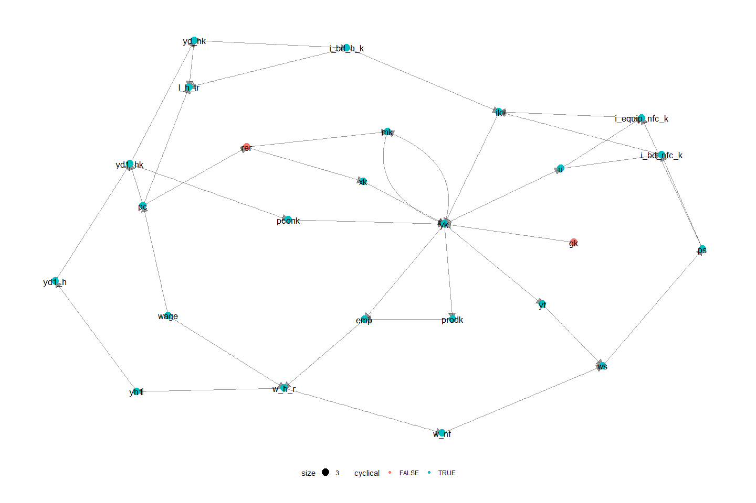

## Appendix 2: Sensitivity analysis

To make sure that the results obtained in this paper, as well as the conclusion derived from these results are not affected by small changes of crucial coefficients in the model. We perform a sensitivity test of the most influential parameters in the shocks.

Figure A2‑1: Sensitivity of the relationship between the maximum level of income insurance, and the average level of income insurance.

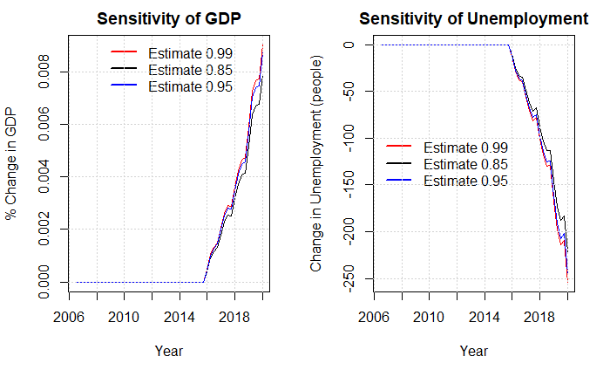

In the plot above we look at the estimate going into the equation of the average income insurance when performing the shock in scenario 1. We know that the estimate should be between 0.85 and 1 as the fraction of receivers of the maximum level of income insurance is 0.85. And no more than 100% can receive the maximum level.

Figure A2‑2: Sensitivity of the minimum wage-gap limit

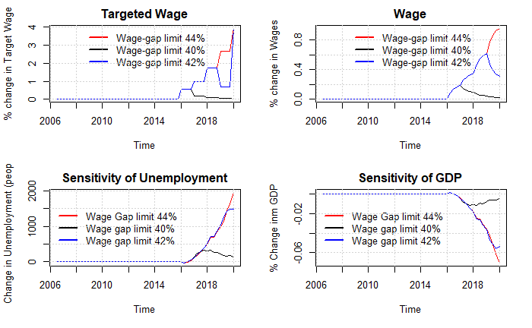

In the plot above we test a central parameter used for the results of this paper being the estimate used for the wage channel setting the limit that the worker unions will allow for the wage gap. As we don’t observe this limit in the data it is hard to find any evidence that backs up the value of this parameter. We use the empirical results from (Fredriksson & Söderström, 2020) setting the minimum wage gap allowed to be 42% of the wage. In the plot below, we see the effects of changing this limit to 40% or 44%.

Figure A1‑3: Relaxing assumptions in the productivity channel

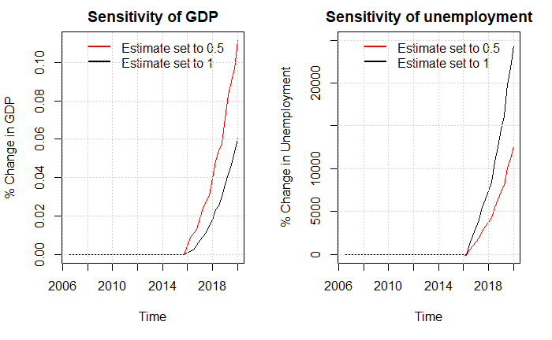

In the figure above we focus on the productivity channel, we mostly exclude this channel due to the lack of empirical justification as well as the radical results found in scenario 5. In an attempt to make the shock more realistic we relax the assumption that firms from one period to another can adjust employment to match the demand, we now obtain much lower effects on unemployment. But the overall match between simulated data and real data is very weak, making these results less trustworthy.

Figure A2‑4: Including the productivity channel in scenario 6.

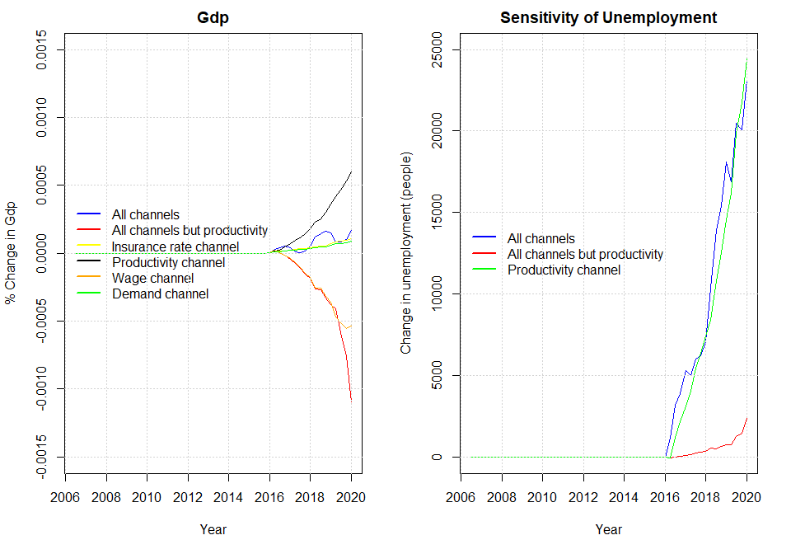

As argued above we exclude the productivity channel in scenario 6 when letting the channels interact. As we mainly use the results from scenario 6 to evaluate the decision to suppress the state regulation percentage, we now show the effects of not excluding the productivity channel when finding these results. As mentioned in the paper, we now obtain an elasticity of 3 of the macroeconomic effects.

Figure A2‑5: Removing autonomous consumption, restricting estimate of the profit-share to -0.1 from -0.45.

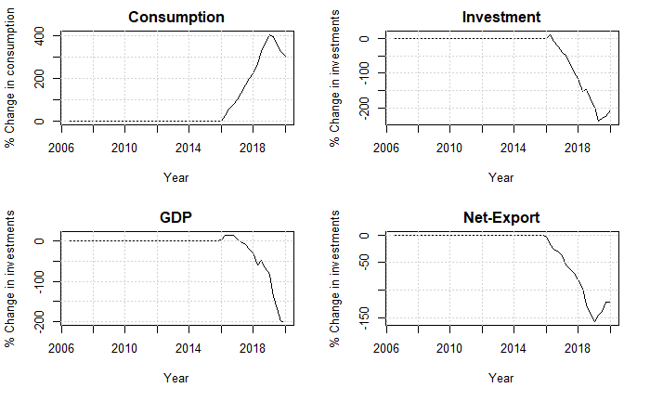

Figure A2-6: Removing autonomous consumption, restricting estimate of the profit-share to 0.1 from 0.45, and setting estimate of real exchange rate on exports to - 0.1 instead of -0.24

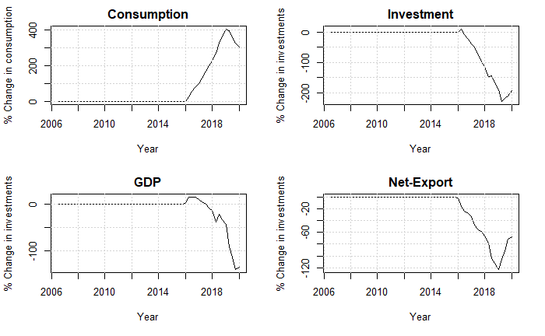

In the two plots above we test the sensitivity of Denmark being categorized as profit led. We do so by changing important coefficients in the investment, consumption and export function. In the last plot we see that the increase in consumption is actually larger than the decrease of investments and net-exports, but as the real government spending is falling (due to nominal government spending being exogenous in the mode) GDP is still decreasing. Here we conclude that really large changes are necessary to define Denmark as wage led.

## Appendix 3: List of equations of the full model and related symbols

As done in the paper, capital letters denote nominal variables and lower-case letters denote real variables.

|  |  |
| --- | --- |
| **Non-Financial Corporations** |  |
|  | (A. 1) |
|  | (A. 2) |
|  | (A. 3) |
|  | (A. 4) |
|  | (A. 5) |
|  | (A. 6) |
|  | (A. 7) |
|  | (A. 8) |
|  | (A. 9) |
|  | (A. 10) |
|  | (A. 11) |
|  | (A. 12) |
|  | (A. 13) |
|  | (A. 14) |
|  | (A. 15) |
|  | (A. 16) |
|  | (A. 17) |
|  | (A. 18) |
|  | (A. 19) |
|  | (A. 20) |
|  | (A. 21) |
|  | (A. 22) |
|  | (A. 23) |
|  | (A. 24) |
|  | (A. 25) |
|  | (A. 26) |
|  | (A. 27) |
|  | (A. 28) |
|  | (A. 29) |
|  | (A. 30) |
|  | (A. 31) |
|  | (A. 32) |
|  | (A. 33) |
|  | (A. 34) |
|  | (A. 35) |
|  | (A. 36) |
|  | (A. 37) |
|  |  |
| **Households** |  |
|  | (A. 38) |
|  | (A. 39) |
|  | (A. 40) |
|  | (A. 41) |
|  | (A. 42) |
|  | (A. 43) |
|  | (A. 44) |
|  | (A. 45) |
|  | (A. 46) |
|  | (A. 47) |
|  |  |
|  | (A. 48) |
|  | (A. 49) |
|  | (A. 50) |
|  | (A. 51) |
|  | (A. 52) |
|  | (A. 53) |
|  | (A. 54) |
|  | (A. 55) |
|  | (A. 56) |
|  | (A. 57) |
|  | (A. 58) |
|  | (A. 59) |
|  | (A. 60) |
|  | (A. 61) |
|  | (A. 62) |
|  | (A. 63) |
|  | (A. 65) |
|  | (A. 66) |
|  | (A. 67) |
|  | (A. 68) |
|  | (A. 69) |
|  | (A. 70) |
|  | (A. 71) |
|  | (A. 72) |
|  | (A. 73) |
|  | (A. 74) |
|  | (A. 75) |
|  | (A. 76) |
|  | (A. 77) |
|  | (A. 78) |
|  | (A. 79) |
|  |  |
| **Financial Sector** |  |
|  | (A. 80) |
|  | (A. 81) |
|  | (A. 82) |
|  | (A. 83) |
|  | (A. 84) |
|  | (A. 85) |
|  | (A. 86) |
|  | (A. 87) |
|  | (A. 88) |
|  | (A. 89) |
|  | (A. 90) |
|  | (A. 91) |
|  | (A. 92) |
|  | (A. 93) |
|  | (A. 94) |
|  | (A. 95) |
|  | (A. 96) |
|  | (A. 97) |
|  | (A. 98) |
|  | (A. 99) |
|  | (A. 100) |
|  | (A. 101) |
|  | (A. 102) |
|  | (A. 103) |
|  |  |
| **Government** |  |
|  | (A. 104) |
|  | (A. 105) |
|  | (A. 106) |
|  | (A. 107) |
|  | (A. 108) |
|  | (A. 109) |
|  | (A. 110) |
|  | (A. 111) |
|  | (A. 112) |
|  | (A. 113) |
|  | (A. 114) |
|  | (A. 115) |
|  | (A. 116) |
|  |  |
| **Rest of the world** |  |
|  | (A. 117) |
|  | (A. 118) |
|  | (A. 119) |
|  | (A. 120) |
|  | (A. 121) |
|  | (A. 122) |
|  | (A. 123) |
|  | (A. 124) |
|  | (A. 125) |
|  | (A. 126) |
|  | (A. 127) |
|  | (A. 128) |
|  | (A. 129) |
|  | (A. 130) |
|  | (A. 131) |
|  | (A. 132) |
|  |  |
| **Labour market** |  |
|  | (A. 133) |
|  | (A. 134) |
|  | (A. 135) |
|  | (A. 136) |
|  | (A. 137) |
|  | (A. 138) |
|  | (A. 139) |
|  | (A. 140) |
|  | (A. 141) |
|  | (A. 142) |
|  | (A. 143) |
|  | (A. 144) |
|  | (A. 145a) |
|  | (A. 146) |
|  | (A. 147) |
|  | (A. 148) |
| **Wage channel equations:** |  |
|  | (A. 145b) |
|  |  |
| **Insurance rate channel equations:** |  |
|  | (A. 149) |
| **Labor-force channel equations:** |  |
|  | (A. 150) |
|  | (A. 151) |
| **Productivity channel equations:** |  |
|  | (A. 152) |

**Symbols**:

N = non-financial corporations, F = financial corporations, G = government, H = Households, W = Rest of the World

|  |  |
| --- | --- |
| Notation | Description |
|  | Nominal GDP |
|  | Nominal Private Consumption |
|  | Nominal Gross fixed capital formation |
|  | Noninal Exports of goods and services |
|  | Nominal Imports of goods and services |
|  | GDP deflator |
|  | Real GDP |
|  | Real Private Consumption |
|  | Real Gross fixed capital formation |
|  | Real Exports of goods and services |
|  | Real Imports of goods and services |
|  | Nonfinancial corporations Nominal Investment in Buildings and Dwellings |
|  | Financial corporations Nominal Investment in Buildings and Dwellings |
|  | Households Nominal Investment in Buildings and Dwellings |
|  | Government Nominal Investment in Buildings and Dwellings |
|  | Nonfinancial corporations Nominal Investment in Equipment |
|  | Financial corporations Nominal Investment in Equipment |
|  | Households Nominal Investment in Equipment |
|  | Government Nominal Investment in Equipment |
|  | Price deflator on consumption |
|  | Wage bill paid by firms |
|  | Wage bill received by households |
|  | Wage bill received by the rest of the world |
|  | Total Employment |
|  | Employment hired to the households |
|  | Employment hired to the rest of the world |
|  | Unemployment |
|  | Rate of unemployment |
|  | Labour force |
|  | Population |
|  | Retired people |
|  | Wage rate |
|  | Disposable income |
|  | Disposable income of profit |
|  | Disposable income on wages/transfers |
|  | Change in pension entitlements |
|  | Benefits received by the households |
|  | Benefits received by the households subtracted the amount paid in income insurance |
|  | Benefits received by the households in the form of income insurance |
|  | Savings |
|  | Aggregate gross operating surplus |
|  | Sectoral gross operating surpluses |
|  | Net interest income on interest bearing assets |
|  | Net interest income on insurance |
|  | Net dividends |
|  | Net indirect taxes |
|  | Income taxes |
|  | Social contributions |
|  | Social benefits |
|  | Other current transfers |
|  | GDP at factor costs |
|  | Profit share |
|  | Labour productivity |
|  | Capacity utilization |
|  | Tobin’s q |
|  | Real exchange rate |
|  | Nominal exchange rate |
|  | Stock of buildings and dwellings |
|  | Stock of capital of equipment |
|  | Net lending |
|  | Current account balance |
|  | Net acquisitions of non-produced non-financial assets |
|  | Capital transfers |
|  | Stock of Equities |
|  | Transaction of equities |
|  | Capital gains on equities |
|  | Nonfinancial corporations’ demand for equities (flow) |
|  | Nonfinancial corporations’ supply of equities (flow) |
|  | Financial corporations’ demand for equities (flow) |
|  | Financial corporations’ supply of equities (flow) |
|  | Households demand for equities issued by nonfinancial corporations |
|  | Households demand for equities issued by financial corporations |
|  | Households demand for equities issued by the rest of the world |
|  | Stock of interest-bearing assets |
|  | Transaction of interest-bearing assets |
|  | Capital gains on interest-bearing assets |
|  | Stock of loans |
|  | Transaction of loans |
|  | Capital gains on loans |
|  | Stock of securities |
|  | Transaction of securities |
|  | Capital gains on securities |
|  | Domestic securities issued by Financial corporations |
|  | Domestic securities held by the rest of the world |
|  | Stock of insurance technical reserves |
|  | Transaction of insurances |
|  | Capital gains on insurances |
|  | Financial net wealth |
|  | Net wealth |
|  | Maximum level of income insurance |
|  | Rate adjustment percentage |
|  | State regulation percentage |
|  | Adjustment percentage |
|  | Compensation rate |
|  | Average amount of income insurance received per person in the IS-program. |
|  | The rate of people being member of the IS-program. |
|  | Inflation |

**Parameters**

|  |  |
| --- | --- |
|  | Net indirect tax rate |
|  | Income tax rate levied Households |
|  | Income tax rate levied on nonfinancial corporations |
|  | Income tax rate levied on financial corporations |
|  | Price deflator of building and dwellings |
|  | Price deflator of Equipment |
|  | Price deflator of imports |
|  | Price deflator of exports |
|  | Price deflator of public consumption |
|  | International price index |
|  | Depreciation rates of the capital stock |
|  | Interest rate on interest-bearing assets |
|  | Interest rate on securities |
|  | Interest rate on loans |
|  | Interest rate on insurance technical reserves |
|  | Dividend distribution rate |
|  | Households share of equities issued by nonfinancial corporations |
|  | Households share of equities issued by financial corporations |
|  | Minimum wage-gap allowed by the workers unions. |

## Appendix 4: estimation of behavioral equations

### Baseline:

Figure A4‑1: Households Consumption

Figure A4‑21a: Households investments in buildings and dwellings

Figure A4‑2b: Summary of regression above

Figure A4‑22: Benefits received by Households subtracted with the amount paid in income insurance

Figure A4‑23: Households demand for loans

Figure A4‑24: Households demand for equities

Figure A4‑25: Households contribution to the pension system

Figure A4‑26: Exports

Figure A4‑27: Imports

Figure A4‑28a: Non-financial Corporations’ investment in buildings and dwellings

Figure A4‑8b: Summary statistics for regression above

Figure A4‑9a: Non-financial Corporations’ investment in equipment

Figure A4‑9b: Summary statistics for regression above

Figure A4‑10a: Prices

Figure A4‑10b: Summary statistics for regression above

Figure A4‑11: Wages

### Regressions for Scenarios

Figure A4‑12: productivity of workers

Figure A4‑12: Labor force

Figure A4‑13: Insurance rate

1. Benefits received if you do not meet the requirements of income insurance program.
2. In our opinion this assumption is quite unrealistic, but not many seems to criticize this assumption.
3. In the case of Denmark, we would expect this reverse effect to be lower, due to the effects of an active labor policy.
4. Morten Aastrup writes under the organization” Landsorganisationen”, Magnus Jensen and Asbjørn Nørregaard writes under the organization ”Cevea”, and lastly Lizette Risgaard writes under the organization ”Fagbevægelsens Hovedorganisation”
5. A detailed presentation of the model can be found in Byrialsen et al. (2022).
6. It is important to point out, that no supply effect between unemployment benefits and labour force is integrated in the model. Despite the importance of this effect in microfounded studies, we didn’t manage to establish any significant empirical link between unemployment benefits and labour force.
7. As the ministry of finance calculates the maximum level of income insurance once a year, we estimate it for the first quarter hereafter keeping it fixed.
8. If the increase in the maximum level of income insurance is because of an increase in wages, people not at the maximum level of income insurance will still experience an increase as the level of income insurance is calculated based on the higher wages. If the increase in maximum level of income insurance is not coming from the wages, it will only increase the income insurance for the 85% receiving the maximum level.
9. The share of people being a member of the income insurance program.
10. There does not exist much international evidence for this channel, as in many countries it is required to be part of the income insurance program.
11. Thereby we leave out the two effects mentioned in section 2, that one would expect the ones with the lowest change of unemployment to leave the program first. As well as one would expect the lower insurance rate to reduce the flexibility of firms.
12. The reason for leaving out a productivity channel is first of all that we find weak empirical evidence for both savings and the level of income insurance having an effect on the productivity, just like the literature we therefore have a hard time finding empirical evidence for the matching effect, when changing the level of income insurance.
13. The investment of firms also depend on the profit share, which is very likely to be affected negatively by an increase in level of unemployment benefits.
14. We do not see this as a problem, as we are mostly interested in the effects on unemployment.
15. One possible critic of this method is that the effects from the income insurance model and the model built in this paper will not interact. We don’t see this affecting the overall results, as it will have no effect on the most dominant channel being the wage channel.
16. Evaluated in 2025, so that the full effects have been carried through.
17. As the participation rate is fixed the fall in employment will directly result in an increase in unemployment of the same amount.
18. As they look at a micro foundation they use the unemployment duration of one person, we will use the amount of unemployed in the economy.
19. As this is the estimated value for 2016, where the suppressing of the state regulation percentage started.
20. We use the value of 2016, as this is the year the suppressing of the state regulation percentage started.